Advanced Bank Loan Data Analysis: Empowering Decision-Making through Dynamic Insights
Power BI Desktop
Problem Statement: Advanced Dashboard Development for Loan Data Analysis. The current approach to loan data analysis lacks depth and interactivity, hindering the ability to derive meaningful insights for informed decision-making. Traditional reporting methods fall short in providing a comprehensive view of lending operations, borrower behavior, and loan performance metrics. There is a pressing need for advanced dashboard design to address these limitations and unlock the full potential of our loan data.
Objective: Our objective is to craft a suite of interconnected dashboards that deliver dynamic and comprehensive insights into our loan data, empowering decision-makers with actionable intelligence derived from robust data analysis. These dashboards are meticulously designed to offer a holistic perspective on our lending operations, borrower demographics, loan performance, and financial metrics, facilitating strategic decision-making based on data-driven insights.
Dashboard 1: Executive Summary
Purpose: This dashboard provides an overview of critical Key Performance Indicators (KPIs) essential for evaluating the overall efficiency and performance of our lending endeavors.
Key Features:
- Total Loan Applications: Monitor total and Month-to-Date (MTD) applications, scrutinizing Month-over-Month (MoM) trends for actionable insights.
- Total Funded Amount: Evaluate the cumulative disbursed funds and track MTD disbursements, analyzing MoM variations to discern funding patterns.
- Total Amount Received: Assess cash inflows via total and MTD received amounts from borrowers, scrutinizing MoM fluctuations for financial health assessment.
- Average Interest Rate: Determine the cost of lending by computing and tracking the average interest rate across all loans, including MTD and MoM changes.
- Average Debt-to-Income Ratio (DTI): Evaluate borrowers' financial resilience by calculating the average DTI for all loans and monitoring

BANK LOAN REPORT | SUMMARY
Power BI Desktop

Total Loan Applications
Average DTI
13.3%
MTD MoM
13.7% 2.7%
Total Funded Amount
$435.8M
MTD MoM
$54.0M 13.0%
Average Interest Rate
12.0%
MTD MoM
12.4% 3.5%
Total Amount Received
$473.1M
MTD MoM
$58.1M 15.8%

38.6K

MTD
4.3K
MoM
6.9%

Good Loan Issued
Overview
Summary
Introduction
Good Loan Applications
Bad Loan Issued
Bad Loan Applications

State :
Details
Loan Status | Total Loan Applications | Total Funded  Amount | Total Amount  Received | MTD Funded  Amount  V | MTD Received  Amount | Avg. Interest  Rate | Avg. DTI
Fully Paid | 32145 | $351,358,350 | $411,586,256 | $41,302,025 | $47,815,851 | 11.64% | 13.17%
Charged Off | 5333 | $65,532,225 | $37,284,763 | $8,732,775 | $5,324,211 | 13.88% | 14.00%
Current | 1098 | $18,866,500 | $24,199,914 | $3,946,625 | $4,934,318 | 15.10% | 14.72%
Total | 38576 | $435,757,075 | $473,070,933 | $53,981,425 | $58,074,380 | 12.05% | 13.33%

86.2%
Good Loan Funded Amount

Good Loan Received Amount

13.8%
Bad Loan Funded Amount

Bad Loan Received Amount

All V

Grade :

All V

Good vs Bad Loan :
LOAN STATUS








All V

BANK LOAN REPORT | OVERVIEW
Power BI Desktop

Total Loan Applications
Average DTI
13.3%
MTD MoM
13.7% 2.7%
Average Interest Rate
12.0%
MTD MoM
12.4% 3.5%
Total Funded Amount
$435.8M
MTD MoM
$54.0M 13.0%
Total Amount Received
$473.1M
MTD MoM
$58.1M 15.8%

38.6K

MTD
4.3K
MoM
6.9%

Introduction

Total Loan Applications by Month
Summary

3.5K

3.8K

4.0K
Overview

4.3K
Total Loan Applications by State Total Loan Applications by
Term
36 months 60 months

Select Measure :

2.3K
Details

2.3K

2.6K

2.8K

2.9K
3.2K
3.4K
3.4K
10K (26.8%)

28K

Jan Feb Mar Apr May Jun Jul Aug Sep Oct Nov Dec
Total Loan Applicati… V
(73.2%)

State :
All V
Total Loan Applications by Employee Length

10+ years

8.9K
Total Loan Applications by Purpose

Debt consol…

18K
Total Loan Applications by Home Ownership

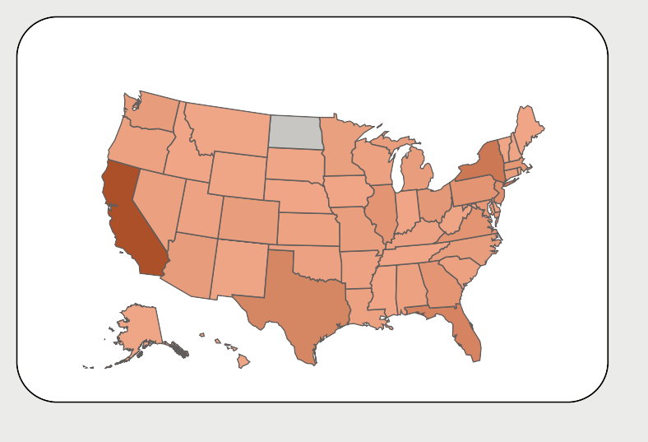


Grade :

All V

Good vs Bad Loan :

All V
< 1 year
- years
- years
- years
- years
1 year
- years
- years

2.2K
1.8K
4.6K
4.4K
4.1K
3.4K
3.3K
3.2K
credit card 5K
other 4K
RENT

18K
MORTGAGE

17K

home impr… 3K
major purch… 2K
small busin… 2K
car 1K
wedding 1K
medical 1K

BANK LOAN REPORT | DETAILS
 |  |  | Total Loan Applications  38.6K  MTD MoM  4.3K 6.9% |  | Total Funded Amount  $435.8M |  |  | Total Amount Received Average Interest Rate  $473.1M 12.0%  MTD MoM MTD MoM |  |  |  |  | Average DTI  13.3%
 |  |  |  |  | MTD MoM |  |  |  |  |  |  |  | MTD MoM
  Introduction Summary Overview Details  State :  All  Grade :  All  Good vs Bad Loan :  All |  |  |  |  | $54.0M | 13.0% |  | $58.1M 15.8% 12.4% 3.5% |  |  |  |  | 13.7% |  | 2.7%
 |  |  | ID | Purpose | Home Ownership |  | Grade | Sub Grade | Issued Date | Funded Amount  V | Interest Rate | Installment |  | Received Amount
 |  |  | 632417 | small business | OWN |  | F | F1 | Tuesday, May 11,  2021 | $35,000 | 0.20 | 932.17 |  | $10,430
 |  |  | 653921 | renewable_energy | MORTGAGE |  | D | D5 | Thursday, March 11, 2021 | $35,000 | 0.16 | 851.51 |  | $39,846
 |  |  | 668166 | credit card | MORTGAGE |  | G | G2 | Thursday, | $35,000 | 0.20 | 936.66 |  | $53,494
 |  |  |  |  |  |  |  |  | February 11,
 |  |  |  |  |  |  |  |  | 2021
 |  |  | 670409 | Debt consolidation | RENT |  | F | F3 | Thursday, | $35,000 | 0.19 | 907.73 |  | $49,122
 | V |  |  |  |  |  |  |  | February 11,
 |  |  |  |  |  |  |  |  | 2021
 | V |  | 672549 | credit card | MORTGAGE |  | E | E3 | Thursday, | $35,000 | 0.17 | 872.48 |  | $52,349
 |  |  |  |  |  |  |  |  | February 11,
 |  |  |  |  |  |  |  |  | 2021
 |  |  | 672680 | Debt consolidation | OWN |  | E | E1 | Thursday, | $35,000 | 0.16 | 858.59 |  | $35,479
 |  |  |  |  |  |  |  |  | February 11,
 |  |  |  |  |  |  |  |  | 2021
 | V |  | 673070 | Debt consolidation | MORTGAGE |  | E | E4 | Thursday, | $35,000 | 0.18 | 879.47 |  | $3,511
 |  |  |  |  |  |  |  |  | February 11,
 |  |  |  |  |  |  |  |  | 2021
 |  |  | 673667 | credit card | MORTGAGE |  | D | D5 | Thursday, February 11, | $35,000 | 0.16 | 851.51 |  | $41,509
Power BI Desktop

